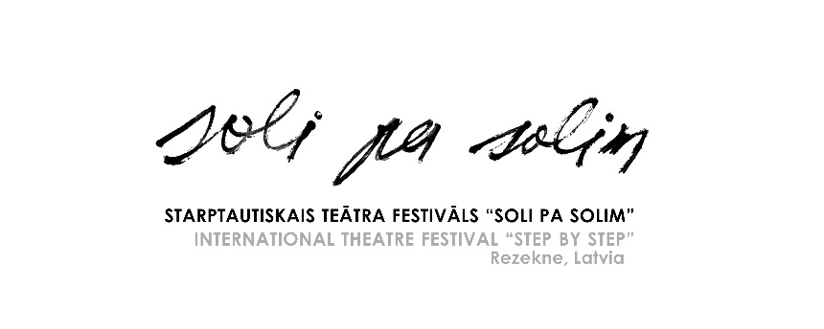

12th International Theatre Festival
“Step by Step”
September 16–18, 2022, Rezekne, Latvia

Name of the festival: The 12th International Theatre Festival “Step by Step”
Web site: http://www.rtt.lv; FB: https://www.facebook.com/rezeknesteatris/
E-mail: teartrezekne@gmail.com
Address: Rezekne Theatre, Bralu Skrindu iela 3, Rezekne, LV-4601, Latvia
Event location: Rezekne, Latvia
Event date: September 16 – September 18, 2022
Deadline for Applications: July 1, 2022 (This year, in view of the war and pandemic situation, we will wait applications only from the Baltic States and the Nordic countries!)

Description:
International Theatre Festival “Step by Step” takes place in Rezekne since 2000. The festival is organized by Rezekne Theatre. The festival offers an opportunity to see various performances of different genres and forms. The discussions are organized after every show, where the theatre groups can meet the audience and hear out their opinion as well as find out the experts’ appraisal. These are lively, exciting, friendly and unforgettable days in Latgale – Eastern region of Latvia.

Performance type: Festival of all kinds of performance styles (small-form theatre shows, comedy, dance, physical, street theatre etc.), also in unusual places and original forms.

Age group of actors: Youth & adult theatre
Performance duration: Up to 60 minutes; if the show is presented in a small space, it might be performed twice during the festival.
Attendees per group: Maximum 8 persons

Financial support: The organizers will provide the participating groups with hostels, full board (three meals a day), and appropriate rehearsing time on stage with technical assistance, and free access to all the events during the festival.
Accommodation (3 nights) and meals are covered for maximum 8 participants of the group.
The travel and transportation costs must be covered by the participants themselves.

How to register: The groups should send
- Application form
- Description of the performance (max 1 page)
- Short description of the group
- List of participants (indicating name, gender, age, function in the group)
- Technical description of the performance (indicating – equipment, lightening necessary)
- 5 photos of the performance
- Full video record of the performance (DVD format or link to material)

