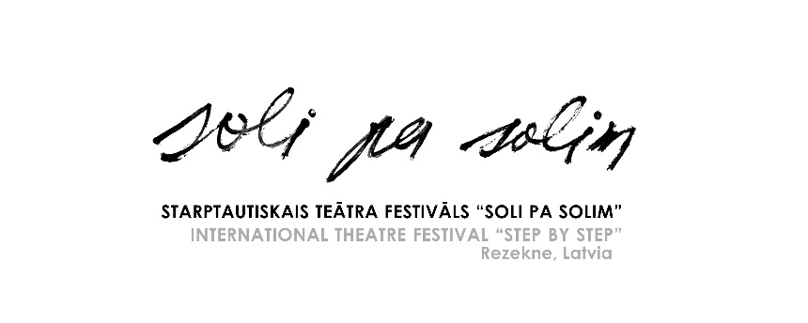

12th INTERNATIONAL THEATRE FESTIVAL “STEP BY STEP”
SEPTEMBER 16–18, 2022, REZEKNE, LATVIA

Application form (This year, in view of the war and pandemic situation, we will wait applications only from the Baltic States and the Nordic countries!)

Name of the company
Director of the company/ Contact person
Address
phone
E-mail
Title of performance
the autHor
Director of performance
Genre of performance |  Drama  Comedy  Tragicomedy  Tragedy  Musical  Poetry  Monodrama  Performance  Street theatre   Pantomime  Claunade  Modern dance show   Other _________________
Length of performance
(max 60 min.)
Setting up time
Removal time
TOTAL NUMBER OF PARTICIPANTS (INCLUDING DIRECTOR)

Please attach the following:
- Description of the performance (max 1 page)
- Short description of the group
- List of participants (indicating name, gender, age, function in the group)
- Technical description of the performance (indicating – equipment, lightening necessary)
- 5 photos of the performance
- Video record of the performance (link to the material or DVD)

Application form to be sent to: teartrezekne@gmail.com
Mara Zalaiskalns, Rezekne Theatre, Bralu Skrindu iela 3, Rezekne, LV-4601; LATVIA
Festival and Rezekne Theatre page: http://www.rtt.lv
FB: https://www.facebook.com/rezeknesteatris/

